RESOLUTION NO.__________

RE: CERTIFICATE OF APPROPRIATENESS UNDER THE
PROVISIONS OF THE ACT OF THE PENNSYLVANIA
LEGISLATURE 1961, JUNE 13, P.L. 282 (53
SECTION 8004) AND BETHLEHEM ORDINANCE NO.
3952 AS AMENDED.

WHEREAS, it is proposed to install a fence in the rear yard on the side property lines at 31 E. Church St.

NOW, THEREFORE, BE IT RESOLVED by the Council of the City of Bethlehem that a Certificate of Appropriateness is hereby granted for the proposal.

Sponsored by:_

_

ADOPTED BY COUNCIL THIS DAY OF

(s)
President of Council

ATTEST:

(s)
City Clerk

HISTORICAL & ARCHITECTURAL REVIEW BOARD

The applicant proposes to replace the existing fence in the rear yard on the side property lines at 31 E. Church St.
APPLICATION #2:

David & Susan Wenner
31 E. Church St.
Bethlehem, PA 18018

OWNER:

__________________________________________________________________

The Board upon motion by Marsha Fritz and seconded by Nancy Shelly adopted the proposal that City Council issue a Certificate of Appropriateness for the following:

- Replace existing fence with a 6 ft. high cedar fence with a lattice top panel.

2. Existing gate will also be replaced.

3. The motion was unanimously approved.

__________________________________________________________________________

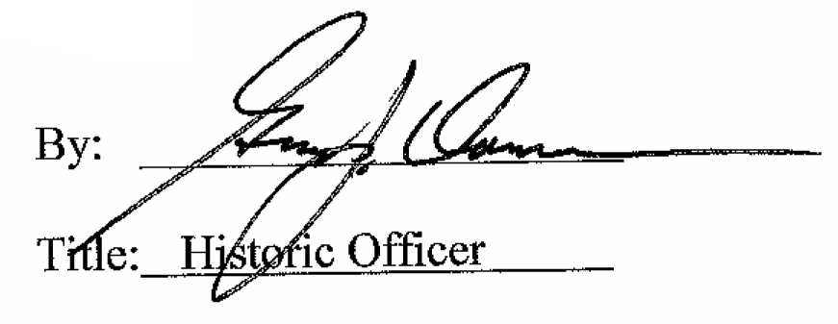

Date of Meeting: March 2, 2016

